Project NZ News

09/08/2021

Ritik

2021

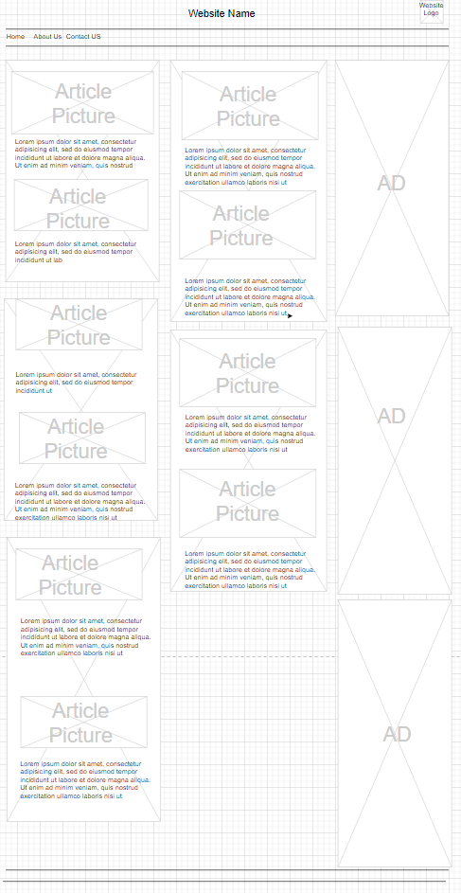**Requirements:**

Wireframe -

Proof of work – To confirm that the project is my own work and has not been copied

Project Plan – The process of creating the project

The website will need to have 8 sections that are listed below:

**Design:**

For the design of the website I have created wireframe with the stake holders requirements

The Title of the website will be aligned to the centre with the logo to the right

3 columns

Column 1

* Technology
* Sport
* Travel

Column 2

* Middle east
* Business

Column 3

* Advertisements

Colum 1 and 2 will have two stories each for each topic with a picture and a couple paragraphs explain the story.

There will be three ads in column 3

**Implementation**:

* First of all, I started by creating the Wireframe for the project



Then created the HTMl file

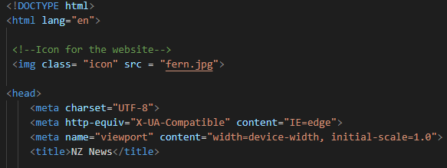

* Researched and gathered the news stores with the information for the website,

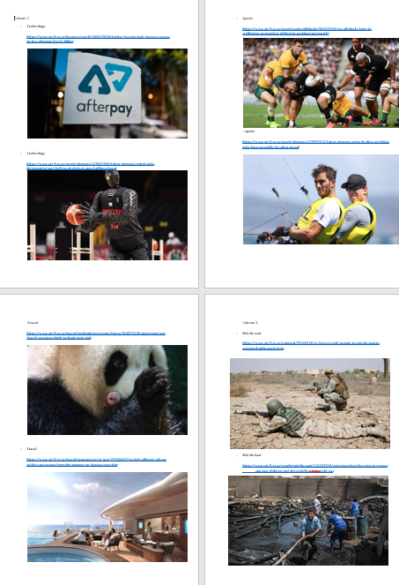

* Created Title and added the navigation bar

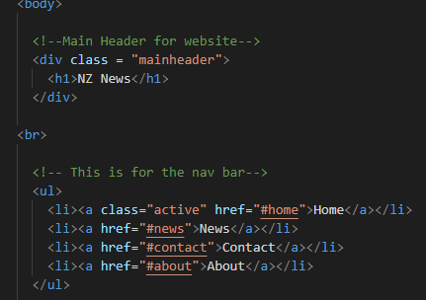

* 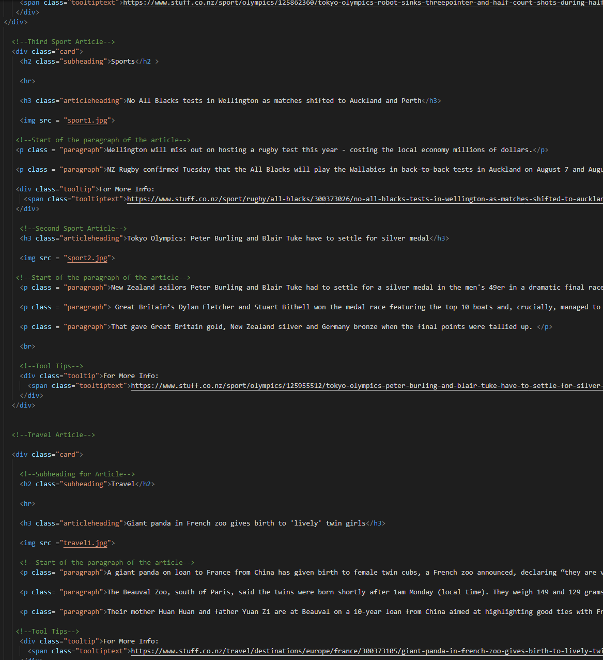Created the 3 columns with the images and the articles.

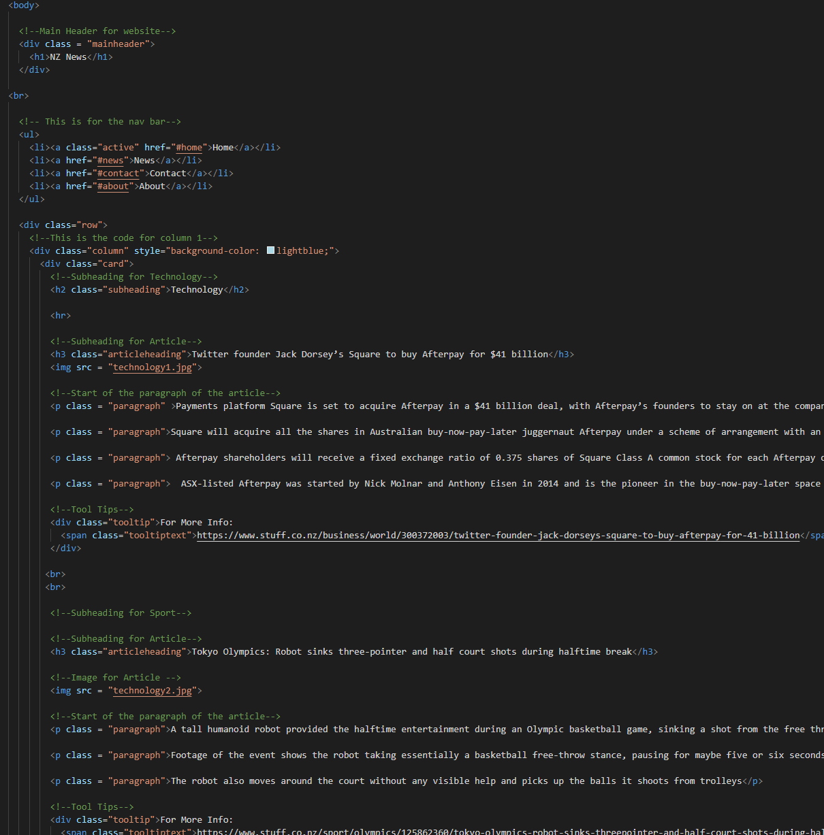

* Added CSS styling to images, text, fonts, tool tips etc.

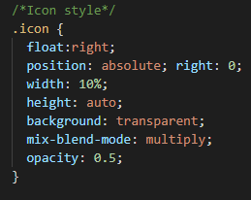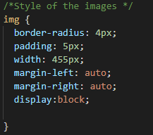

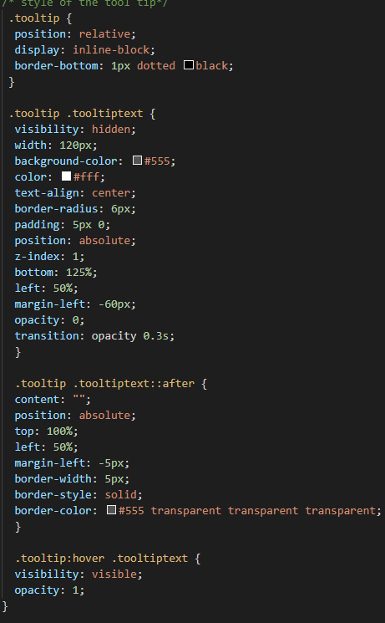

**Verification**

After creating the website, I have gone ahead and tested to confirm that the website is fit for purpose.

I have done this by:

* Making sure that when the mouse is hovered over the nav bar, the colour will change

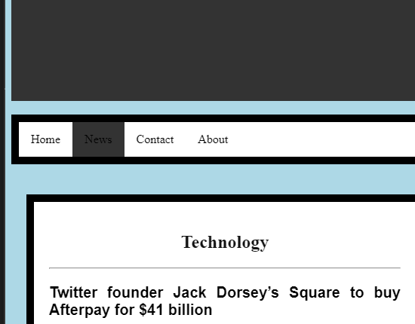

* Tested to make sure that the tool tips show the url

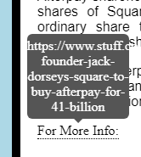

* Confirmed that the all the articles setup the same way i.e text, font, image size





After finishing the testing and verification, I can confirm that website is ready to be deployed in the customer environment.

**Maintenance**

For future maintenance of the website I have added comments to the line of code for the different parts articles

This is so that when in the future, if the website is needing to be updated, each line will have a short description to let the user know what It means.

(Refer to image as an example)

